HR 2 BREAKDOWN

TEAM: [State Team number and Name here]

Due Date:
Friday, March 6, 2020 at 11:59pm

[Advice: Use this template and create a Google Doc or Microsoft Teams doc for your team. Give all team members a set deadline/time to populate their own personal table of Items completed. Once that time hits, have one member in charge of exporting the file into a PDF that you then turn in by your meeting time.]

[Please delete all information highlighted in yellow before turning this in. Do not highlight your own information in yellow.]

Provide several pics of the current state of your completed system thus far here:
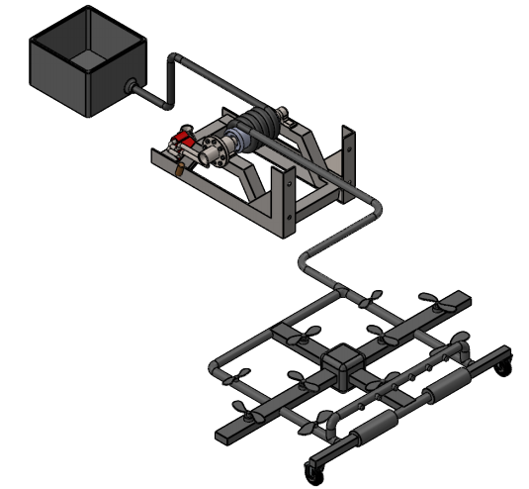
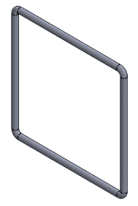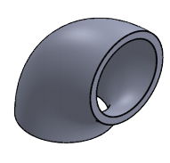
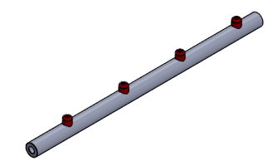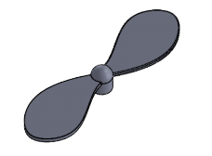
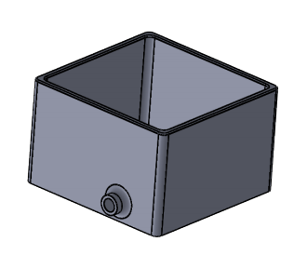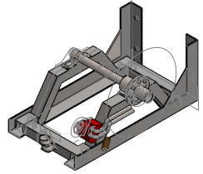
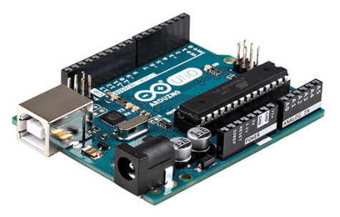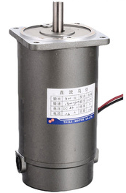

The following are the Action Items each person completed between Hardware Review 1 and Hardware Review 2:

Team Member: Abdalla
Action Item | Date Completed | Result/Proof of Completion
Hose Selection | 07-02-2020 | 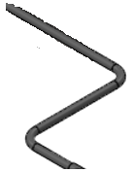
Reel Engine | 07-03-2020 | 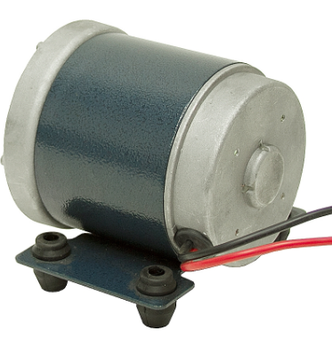

Team Member: Saad
Action Item | Date Completed | Result/Proof of Completion
Brush Roller Selection | 07-02-2020 | 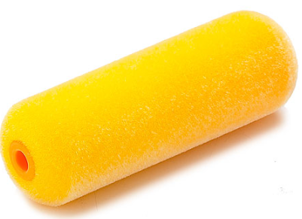
CAD Package | 07-05-2020 | 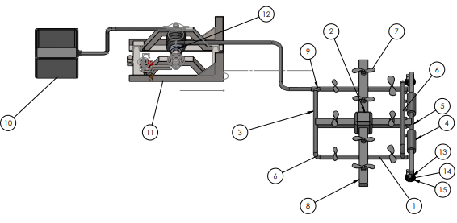

Team Member: Mosaad
Action Item | Date Completed | Result/Proof of Completion
Arduino Board Workout | 07-02-2020

Team Member: Mohamed
Action Item | Date Completed | Result/Proof of Completion
Propellers Motor Selection | 07-02-2020 | 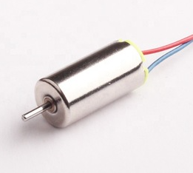

Team Member: Abdulrahman
Action Item | Date Completed | Result/Proof of Completion
Water Pump Selection | 07-04-2020 | 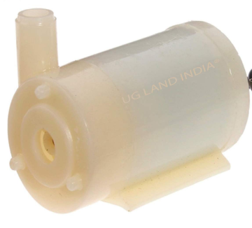

Team Member: Abdullah
Action Item | Date Completed | Result/Proof of Completion
Components Selection (Wires) | 07-04-2020 | 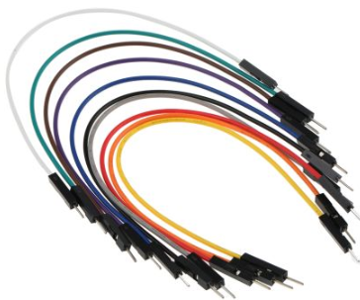

The following are the Action Items for each team member between HR 2 and the Final Product presentation:

Team Member | Action Items | Date Due
Abdalla | - Hose flying operation  - Reel Engine Testing | - 07-20-2020  - 07-23-2020
Saad | - Brush Fabric testing | - 07-20-2020
Mosaad | - Arduino Coding | - 07-20-2020
Mohamed | 1. Propellers Speed and Operation | 1. 07-20-2020
Abdulrahman | 1. Water Pump extraction speed testing | 1. 07-20-2020
Abdullah | 1. Components operations with each other | 1. 07-20-2020

